EXPERIMENT 10
CREATE TABLE STUDENT (
sid INT PRIMARY KEY,
sname VARCHAR(50),
dept VARCHAR(50),
marks INT
);
desc student;
SET SERVEROUTPUT ON;
SHOW SERVEROUT;
CREATE OR REPLACE TRIGGER trg_check1_marks
BEFORE INSERT ON STUDENT
FOR EACH ROW
BEGIN
IF :NEW.marks < 0 THEN
RAISE_APPLICATION_ERROR(-20001, 'Marks cannot be negative');
END IF;
END;
/

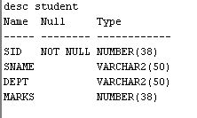
INSERT INTO STUDENT VALUES (1, 'Henry', 'CSE', 38);
INSERT INTO STUDENT VALUES (1, 'Henry', 'CSE', -38);

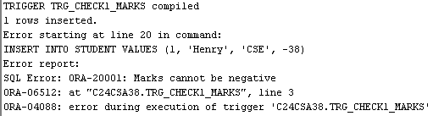

CREATE TABLE customer_details (
cust_id INT,
cust_name VARCHAR(30),
address VARCHAR(30)
);
CREATE TABLE emp_details (
empid INT,
empname VARCHAR(30),
salary INT
);
CREATE TABLE cust_count (
count_row INT
);
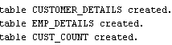

1.CREATE OR REPLACE TRIGGER tri
AFTER INSERT ON customer_details
FOR EACH ROW
BEGIN
DBMS_OUTPUT.PUT_LINE('A row is inserted');
END;
/
INSERT INTO customer_details (cust_id, cust_name, address)
VALUES (1, 'Ellen', 'Kochi');

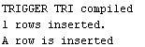

2. CREATE OR REPLACE TRIGGER trig
AFTER INSERT ON emp_details
FOR EACH ROW
WHEN (NEW.salary > 20000)
BEGIN
DBMS_OUTPUT.PUT_LINE('Salary is greater than 20000');
END;
/
INSERT INTO emp_details(empid, empname, salary)
VALUES (2, 'Jayden', 30000);

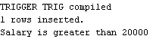
3. CREATE OR REPLACE TRIGGER trigg
BEFORE INSERT OR DELETE ON customer_details
FOR EACH ROW
BEGIN
IF DELETING THEN
UPDATE cust_count
SET count_row = count_row - 1;
ELSE
UPDATE cust_count
SET count_row = count_row + 1;
END IF;
END;
/

INSERT INTO customer_details VALUES (1, 'Ansa', 'Kannur');
DELETE FROM customer_details WHERE cust_id = 1;
SELECT * FROM cust_count;
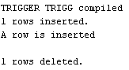
4. CREATE OR REPLACE TRIGGER trigge
BEFORE DELETE OR UPDATE ON emp_details
FOR EACH ROW
BEGIN
IF DELETING THEN
INSERT INTO deleted
VALUES (:OLD.empid, :OLD.empname, :OLD.salary);
ELSE
INSERT INTO updated
VALUES (:NEW.empid, :NEW.empname, :NEW.salary);
END IF;
END;
/
DELETE FROM emp_details WHERE empid = 2;
SELECT * FROM deleted;
UPDATE emp_details
SET salary = 10000
WHERE empid = 1;
SELECT * FROM updated;

